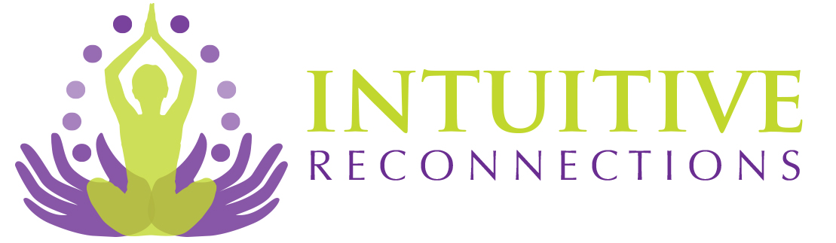

Treasure Mapping

Contrary to popular belief, the best time to create a vision board is in early April. The Aries new moon is when the astrological New Year begins, so in star charts, it is seen as the beginning of the year.

In traditional cultures, Spring was the beginning of the year, on the equinox, which is March 20. The astrological calendar ends with Pisces (Feb 21-March 20) and begins with Aries (March 21-April 20).

Aries is sometimes called the newborn baby of the Zodiac. In astrological terms, a Pisces has been through all the stages of life, and as a being in the 12th house, has experienced all of the other Zodiac signs in past lives. So a Pisces would be the oldest sign with the oldest soul, and an Aries would be the youngest.

It makes sense, then, to begin our Treasure Maps on the Aries new moon, in April. Aries marks the transition from the last water sign to the first fire sign. Any fire time is a good time to decide what new projects we want to do. The other fire time is late summer, in Leo. Fire energy can light a match under new projects and get them moving.

This may be why many people start their Vision Boards in December, which is in Sagittarius (another fire sign), but at this time many people are in the middle of winter, a time for dormancy and rest.

A Treasure Map lays out all of what you want to attract into your life. It can be covered with pictures or phrases. Mine is simple writing in a grid of 12.

The categories are:

Health
Learning
Habits
Family
Goals
Serenity
Spirituality
Friends
Passions
Abundance
Callings
Creativity

The categories can be anything you desire. Under each one I list those things I am working on and have not yet accomplished. Over the years my Treasure Maps have changed.

I previously focused on mostly material things, and work. Now that most of those things have come to fruition, I focus more on the creative side of life and what brings me joy.

Check in every year to when the Aries new moon will take place, and plan your Vision Board then! You will be glad you did.

If you have questions about this class, direct message, email, or text me at 407-490-8621.

Note: this is a sample class. Paid classes are longer and have more material. Thank you for downloading this class!

Copyright 2020 Intuitive Reconnections, PLLC All Rights Reserved

